TBI Monte Carlo: more information
Levi Burns

The MC results for the two phantoms are in MIM
Case #1 (from the paper/my thesis) – “TBI PHANTOM B2” in MIM (ANON70346) – the one with two pieces of lead
Case #2 – “TBI PHANTOM” (01262018) – with one piece of lead

Moving files between accounts on Unix: (e.g. for the prone shift part of the pipeline):
- Be in the directory where you are either trying to send files from, or gather files to
- Use “sftp” to sign in to another account from inside that directory.
E.g. sftp tteke@205.233.175.86
- Use “cd” commands to get to where you need to be
- Use either “put” to put a file into the directory you signed in to, or “get” to grab a file to your first directory.
  - Here you can’t use tab autocomplete to get file names, you need to type them out completely.

Executable | Code name (C++)
conv | dose_conv.cc
extend | extend_patient_ID.cc
filtershift | filter_shifter_reschange_id.cc
lead | put_lead_on_top_id.cc
plastic | put_plastic_on_patient_id.cc
read | read_out_vals.cc  (not working on cluster right now… sorry! need to open egsphants manually; someone in the department could probably fix this easily, i have no time left to do so)
sgolay | sgolay3d_final.cc  *better than the clinical one! handles uncertainties better
stacker | phantom_stacker_tt_id.cc
shift_calcs | shift_calcs.cc
strip | dose_strip_final.cc
array_vals | array_vals.cc

A note about file resolution:
- Tony Teke started this project with 0.5 cm resolution phantoms, but in the time between we worked on this project, the MC program was designed to make 0.25 cm resolution phantoms.
- This pipeline relies on 0.25 cm resolution phantoms. It is possible to adjust this, but it would take several days of debugging to change and is probably not worth the effort…

Appropriate grids for the z-direction:
- Some patient phantoms, for some reason, have wonky z grids. For example, they won’t include 0.000 (e.g. they’ll all be offset by 0.100), or sometimes there will be uneven spacing between a few voxels (twice I have seen patients with 0.25047 cm resolution or something like that, but three or four voxels were 0.25048 cm apart)
- If you come across this, the easiest way to solve the problem is to manually erase the z-grid for that phantom and to enter a new one, with the same number of voxels. Make sure your values are 0.25 cm spaced and include 0.0000 as one of the points.
  - I tried using a “zoffset” variable in Matlab for this at one point, but this was sort of finicky. I would still recommend simply resetting the grid manually.
- Can use arrayvals.cc to do this; but you might have to do it in chunks (negative values first, then positive values); it doesn’t like crossing over zero. Still faster to do it this way than typing it all out by hand

Some phantom pictures:
Bed_y: use dosxyzshow to look at the patient CT and find the y-value of the couch by scrolling through the slices and finding the lowest value for y. (Use the XY-plane view) Round this value to closest 0.25 cm.
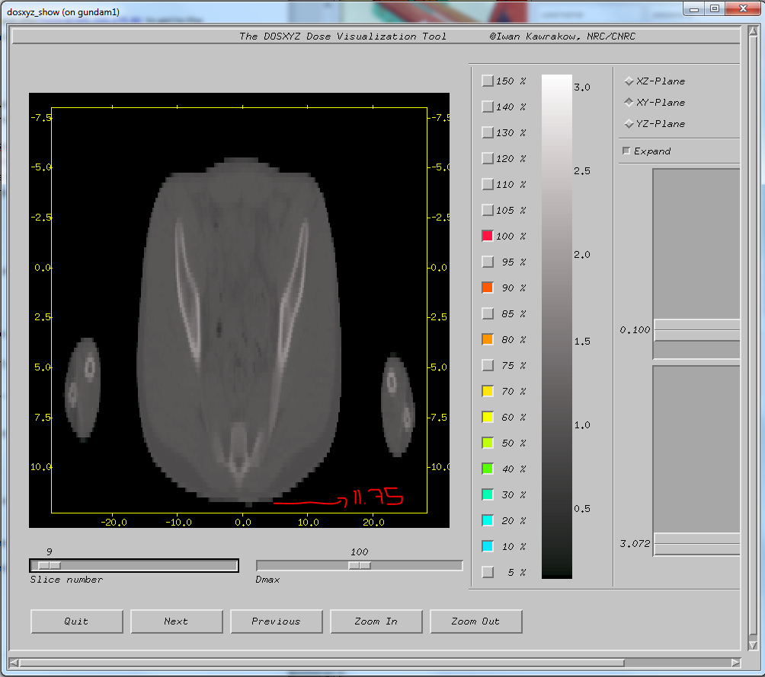

X,y,z coordinates of t0 in DOSXYZnrc for the patient (look in all three views so that you check each point twice, as a sanity check)
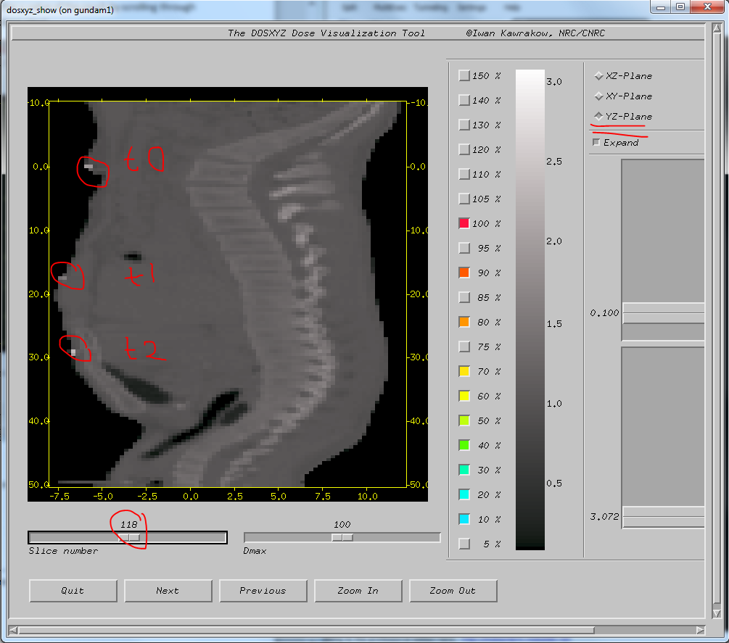
(I’ve circled all three points here so you can see them – but you only need to get t0 coordinates from this.)
Occasionally it can be hard to find the marker – not the end of the world if you’re off by ~0.1 cm, the resolution is only 0.25 cm anyway!
In one patient there was no t0 marker at all, so I made an estimate for its position based on t1 and t2 coordinates, and based on the coordinates in the Excel sheet.

Egsphant file annotation:
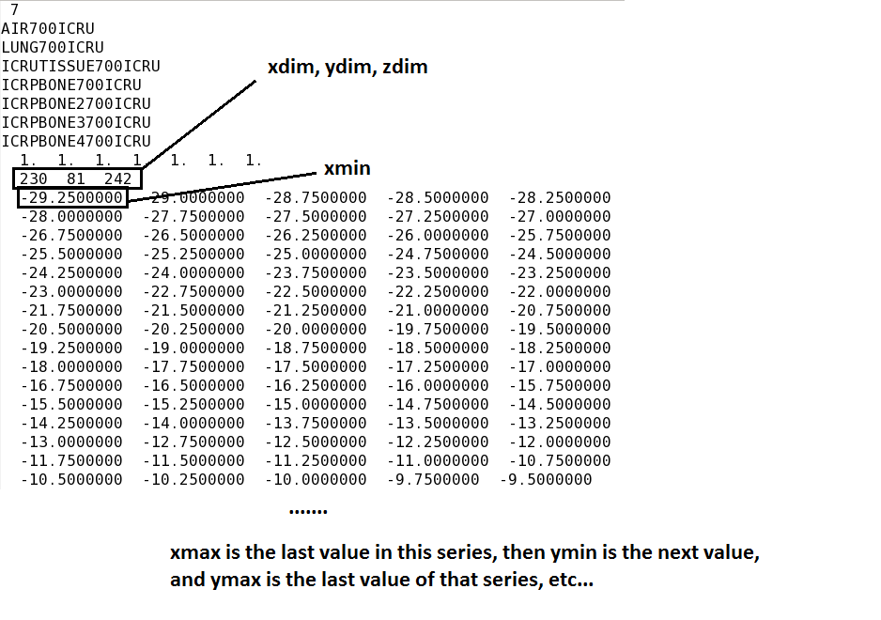

From the Excel patient sheet, you need:
- AP and PA compensator thicknesses
- Z-coordinate for t0, t1, and t2 (z_MCscaled)
- Number of styros
- Treatment date (need the number of days between the treatment date and August 13, 2015)
  - From Aug 13 2015 to Dec 31 2017 there were 871 days
  - Take the number of days elapsed since Jan 1 2018 and add it to 871.

Values to calculate:
(Done automatically with ./shift_calcs, but here for your info)
Shift_y_plastic = (bed_y) – (44.8 – 3.7n)
- n is the number of styros.
Shift_y_lead = shift_y_plastic – plastic_thickness
- the plastic thickness is almost always 0.6 cm. For the TNI table it is 1.6 cm.
Typical values are around -20 to -30 for shift_y_plastic, and -20.6 to -30.6 for shift_y_lead.
SSD = 184.5 – 3.75n – (patient_sep + mat_sep)
- 184.5 cm is the distance from the source to the top of the TBI platform (without styros) and mat sep is the thickness of the TBI mattress (4.0 cm)

Notes
- If you look at the log files or run a simulation not in parallel, you’ll see a lot of “AMASS” error messages. This is because there is an infinitesimal layer of air between the plastic tray and the lung compensators. There are no particle events happening here and so I think it divides by zero or something… but it’s not anything to worry about in the end.
- Hopefully you don’t have more patients with a double set of lung compensators, but if you do, you’ll need to run the Matlab code twice (one for each pair of contourPoints files), and re-compile the put_lead_on_top.cc code to handle the file names. This isn’t hard, but it is not going to run automatically like the pipeline I’ve automated so far.
  - You’ll also need to change the numbers “28” to “30” in the dose_strip_final.cc code and recompile it. This is because you now need to remove 30 layers from the top of the phantom instead of 28 with the extra lead comps there

Extending the phantom:
- Once I had an issue with a patient who was very short and I needed to add air voxels superior to the patient instead of just inferior to the patient. I changed another part of the pipeline so that this probably isn’t necessary anymore for any patients, but if you do find a patient so short that the whole flattening filter can’t fit, use the code “extend_patient_both.cc” and then “dose_strip_final.cc” – there’s a parameter you can edit to make it remove 50 voxels from the top of the patient

IMPORTANT NOTE: Before you run any simulations with this phantom, you need to open the .egsphant and change something manually: Remove the value 10 at the top with 9, delete the repeated medium name, and there are a set of dummy 0s (one per medium type), you need to delete one.
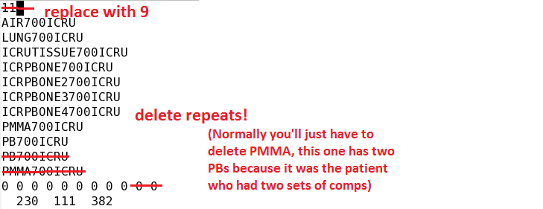
SECOND IMPORTANT NOTE: Before you run any simulations, open this phantom, look at the orientation of the lung comps, and compare it to the plan in Eclipse to make sure you have put the compensators on in the correct orientation.

Making the egsinp file
This is a very simple code, but it is easier to change the hard-coding than it would be to enter arguments. It’s easy to just open the code (emacs Create_egsinp.cc) and change the following variables:
- SSD, Cx, Cy, Cz (for Cy, just adjust the number before the SSD)
- outputFileName
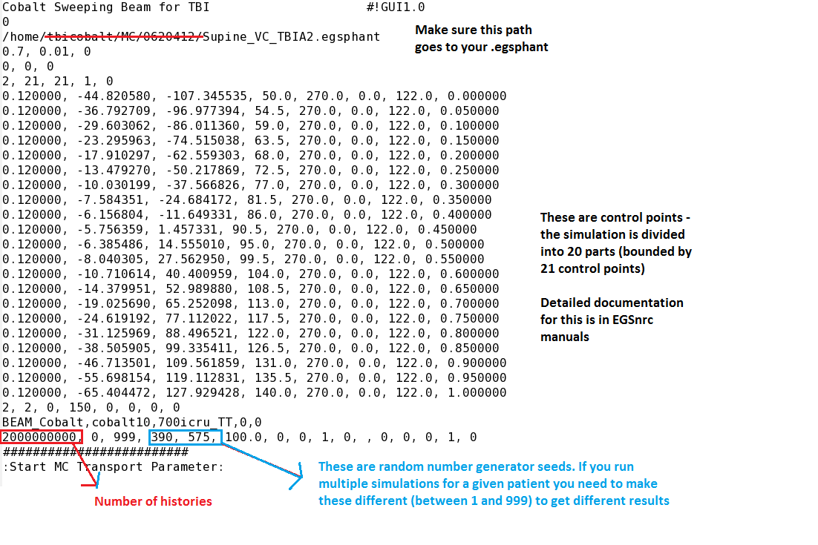
If you are running multiple sub-simulations, you also need to change the random number generator seeds or else you will get the exact same dose results.
In my thesis, I used two simulations of 2B for each treatment – that is, each patient actually had 4 MC simulations. This was a noise reduction technique. I expect that you if you just do one simulation per side, but make sure you use deformable dose registrations, it would be OK – the effect of having two distributions “wash each other out” would work here

Running the simulations
exb dosxyznrc Supine_01S 700icru_TT long batch=at p=256
(Third entry is the egsinp name, without the .egsinp file extension. Fourth entry is a pegs data file that needs to be in HEN_HOUSE. Last entry is the number of cores, you can set it to whatever you want.)
If you didn’t change the NUM_MED and those zeros (and other things mentioned in that line), you are not going to get a successful .3ddose file at the end.
These simulations take around 45-60 minutes for 2 billion histories in a 0.25 cm resolution phantom.
You should delete the intermediate egsphant files after you finish producing the egsphant for a patient – they take up a LOT of space
After the simulation, you also need to remove the *_w* files from dosxyznrc after you retrieve the .3ddose file.

Savitzky Golay filter note:
- The argument “3” means a 7x7x7 grid is used
- The SG code used in RealRA does not handle uncertainties properly; if a dose value is replaced by a smoothed value, then the corresponding uncertainty value is set to zero. I fixed this in my code

Prone shift
The doses from the prone treatment, when loaded into MIM, for some reason are shifted away from the image in the x and y directions. I talked on the phone with Joe Meyes from MIM earlier and we weren’t able to find a way to fix it… but it is probably possible.
After loading the prone image into MIM, use the ruler tool to get a rough idea of what the x and y shifts should be. (Shifting to the right or down are both positive shifts, i.e. you add numbers to the grid instead of subtracting)
Then go back to the 3ddose file, and change the coordinates for x and y. You will need to produce these coordinates in a .txt file and then copy/paste these into the .3ddose file. Then, you re-convert the 3ddose to .dcm, and re-import to MIM.
The file I use to make these .txt files is “arrayvals”. It prompts you as you go through – if you accidentally press a wrong button you’ll have to re-run it (ctrl+C to quit), not a huge deal.

Calibration calculation
Measurements were done with a solid water phantom (20 cm thick, 40x40 cm^2) at depth 10 cm with an ion chamber. Five full sweeps were delivered three times and the average dose rate from these treatments was measured (and a pressure/temperature conversation calculation was applied). The solid water phantom was placed at extended SSD and the TBI flattening filter was in place.
A simulation was run with an identical geometry, with both the solid water and the flattening filter. Five simulations with three billion histories each were run to get strong statistics. The simulated dose in Gy/particle at the measurement point in the simulation was found and used below.

Calculation: (CALIBRATION – exp factor brings us back to calibration day, Aug 13 2015)
$$conv factor= \frac{measured dose rate}{\exp{factor*simulated dose rate}} \\ conv factor= \frac{(0.11866\frac{Gy}{min})}{(0.75393)*(1.353*{10}^{-16}\frac{Gy}{particle})} \\ conv factor=1.1849*{10}^{15} particle/min$$
The value 1.17 *10^15 in my thesis is incorrect (oops). Gives the reader an order of magnitude idea, it was fine-tuned after writing; one small factor was omitted in the first calculation. The exponential factor scales from the measurement date to the August 13 2015 calibration date. (Half-life 1921.5 days)

Compiling the codes:
You only need to use the g++ lines the first time after you change some of the code.
g++ -Wall put_plastic_on_patient_ID.cc –o plastic

g++ -Wall put_lead_on_top_ID.cc –o lead

g++ -Wall extend_patient_ID.cc –o extend

g++ -Wall Filter_shifter_reschange_ID.cc –o filtershift
- need to iterate this step until done; normally ~3 times
- shiftedfilted_VC_TBI01_AP.egsphant is the file to look at
- (these are coordinates of t0)

g++ -Wall phantom_stacker_TT_ID.cc –o stacker

(If you are using anonymized patients, use the codes without the “_ID” in the names – then there is a two-patient ID used above for them.

Other notes:
- Replacing text in the .egsphant files through the emacs editor:
  - Press Alt+X
  - Type “replace-string”
  - It will prompt you for the string that you want to replace; enter it, then press Enter
  - It will prompt you for what you want to enter instead; enter it, then press Enter
  - It will fill in all entries from where your cursor is until the end of the file (make sure your cursor is in the appropriate place before you start!)

- For extremely short patients you will need to use./extend2 instead of ./extend, and /strip2 instead of ./strip
- This code also adds 50 voxels of air superior to the patient instead of just inferior to the patient (to make sure the entire flattening filter fits)

Note: tbi_clin should work, but if for some reason it doesn’t, know that this file is on the student account if you need to find it: (also need cobalt10.egsinp in BEAMnrc and intensity6)
/home/student/HEN_HOUSE/pegs4/data/700icru_TT.pegs4dat

AddDose
I’m not recommending you do multiple simulations of a single patient because it takes multiple times as long to get simulations done, and also makes the process more cumbersome. If you do want to use my weighted mean technique, though, this is how it’s done (adds two steps to the process in total, and also requires the strip/filtering of each sub-simulation
- Strip each resulting dose file
- SG filter each of the stripped dose files
- Change the filenames of each stripped dosefile to have “_1.3ddose”, “_2.3ddose”, etc. as their extensions (that is, the end of the filename before the extension must be an underscore and then an integer – up to how many dose files you have in total)
- Run the add dose script
- SG filter this script
- Convert the final result to a real dose file, as you would do normally
Syntax for the AddDose script:
./add Supine_1224849 3
(the “3” integer is replaced with how many files you want to add together; “Supine_1224849” is whatever the filenames are for the dose files, not including the 3 at the end)

